**Project Design Phase- II**

**Data Flow Diagram & User Stories**

|  |  |
| --- | --- |
| **Date** | **23rd October 2023** |
| **Team ID** | **593053** |
| **Project Name** | **Project - Predicting Mental Health Illness Of Working Professionals Using Machine Learning** |
| **Maximum Marks** | **4 Marks** |

**Data Flow Diagrams:**

A Data Flow Diagram (DFD) is a traditional visual representation of the information flows within a system. A neat and clear DFD can depict the right amount of the system requirement graphically. It shows how data enters and leaves the system, what changes the information, and where data is stored.

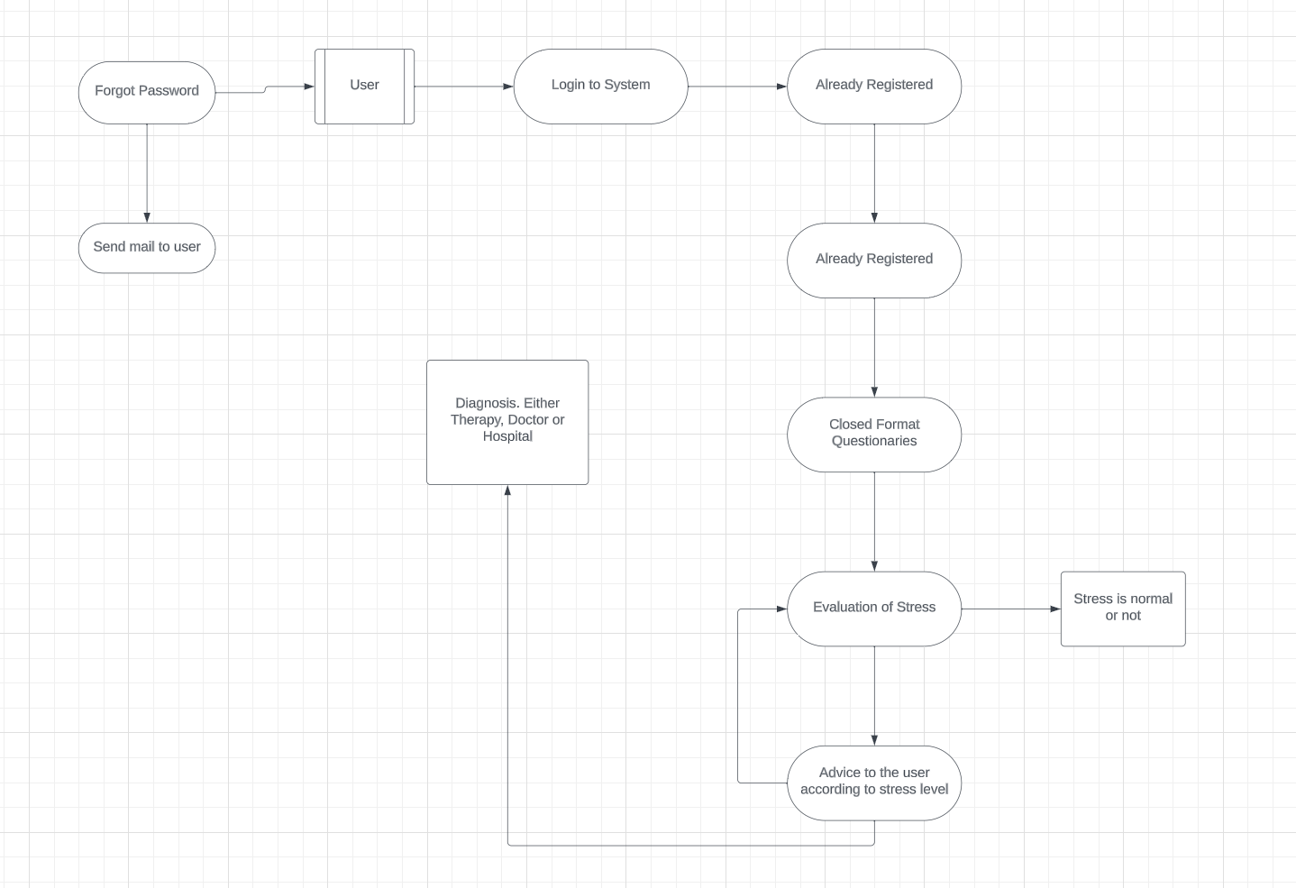

**User Stories**

|  |  |  |  |  |  |  |
| --- | --- | --- | --- | --- | --- | --- |
| **User Type** | **Functional Requirement (Epic)** | **User Story Number** | **User Story/Task** | **Acceptance Criteria** | **Priority** | **Release** |
| Customer | Registration | User 1 | As a user, I can register for the application by entering my email, password, and confirming my password. | I can access my account/dashboard | High | Sprint - 1 |
|  |  | User 2 | As a user, I will receive confirmation email once I have registered for the application | I can receive confirmation  email & click confirm | High | Sprint - 1 |
|  |  | User 3 | As a user, I can register for the application using my Office credentials |  | Low | Sprint - 2 |
|  | Login | User 4 | As a user, I can log into the application by entering email & password |  | High | Sprint - 1 |
|  |  |  |  |  |  |  |
|  |  |  |  |  |  |  |
|  |  |  |  |  |  |  |